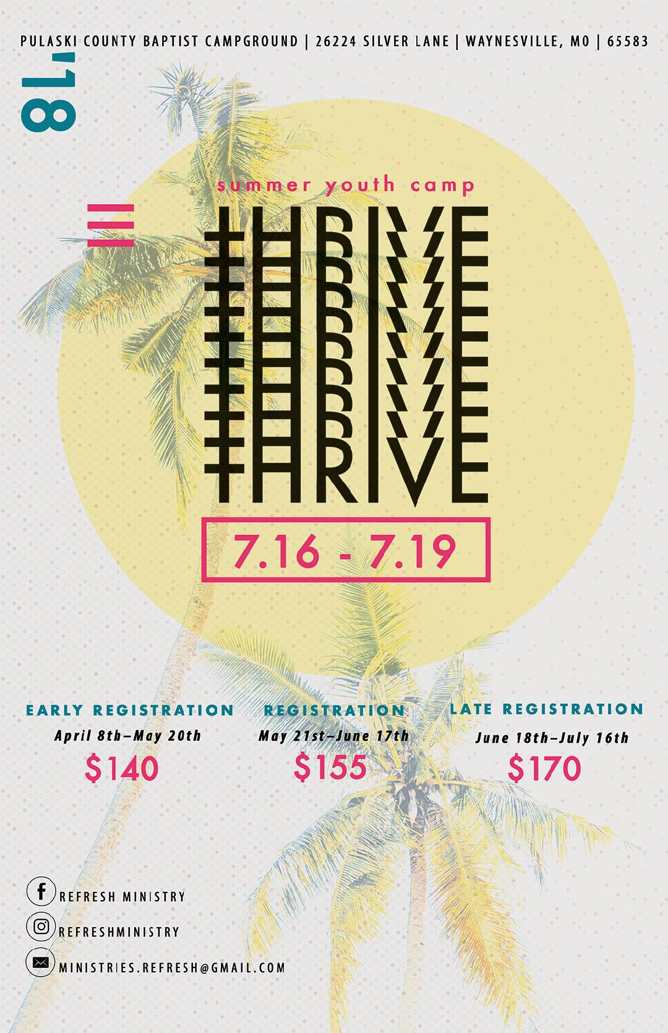FINANCIAL INFORMATION

We are encouraging all churches to participate in early registration, so that REFRESH MINISTRY can better prepare itself. This would be a big help to REFRESH MINISTRY.
Payment Options:
REFRESH MINISTRY will be accepting checks, cashier checks, and money orders. No cash for preregistration. We will be accepting cash on the day of camp.
Please make all checks to:
New Covenant Fellowship Baptist Church
Please send your checks to 3741 S Leawood Ave Springfield, MO 65807.
Any additional questions or concerns about camp registration, please feel free to contact Pastor Aaron Bohyer 417.693.3696 or email ministries.refresh@gmail.com.

*PLEASE NOTE THE REGISTRATION DATES AND PAY THE AMOUNT DURING THE TIME THAT YOU ARE REGISTRATING. THANK YOU.

SPRINGFIELD AREA CHURCHES, please meet at New Covenant Fellowship
201 W State Highway NN Ozark, MO 65721 at 9 am.

ALL OTHER AREA CHURCHES, please be at the camp grounds at 11:30 am.

General Information

Student Information
Name _______________________________________________________
Address _____________________________________________________
City ____________________________________ State ________________
DOB________________ Age_____ Grade_______________
Home Phone______________________________________
T-Shirt Size (circle one) XS S M L XL XXL
Church Information
Church Name ______________________________________________
Address ___________________________________________________
City____________________________ State _______________
Senior Pastor’s Name _________________________________________
Youth Pastor/Chaperone’s Name __________________________________
Church Phone Number __________________________________________
Youth Pastor/Chaperone’s Number ________________________________
Family Information
Parent(s) Name 1.____________________ 2.________________________
Address ______________________________________________________
City________________________ State____________
Primary Phone Number_____________Secondary Number_______________

Medical Release/Liability Release Permission Slip Form
Please Fill Out Completely

Child’s Name:_________________________________ Home Phone (_____) _____-_________
Emergency Contact:___________________ Emergency Contact Phone (_____) _____-_______
Birthday (M/D/Y) _________________________ Sex (M)___(F)____Age:______________
Street Address:_________________________________________________________________
City:_____________________________________________ State:_____Zip:_______________

REFRESH MINISTRY of Ozark, MO
From July 16th, 2018 - July 19th 2018
MEDICAL RELEASE
In the event my child (children) becomes ill or is injured while under church supervision, I authorize the “Person In Charge” (defined as the person in charge of REFRESH MINISTRY of Ozark, MO participation in any church event or the Person In Charge’s designee) to take the following steps in the following order:
1. Contact the parents of the child and follow his/her instructions.
2. In the event of an emergency when neither parent can be contacted, the Person in Charge will immediately attempt to contact the child’s physician and follow his/her instructions.
3. If the child’s physician cannot be immediately reached, the Person In Charge will use their own discretion in contacting a properly licensed practicing physician or the nearest hospital and follow his/her instructions.
4. At the same time as the preceding steps are occurring, I authorize the “Person In Charge” to call for/order emergency medical services for the child.
If in the opinion of a properly licensed and practicing physician my child needs medical or surgical services which require my consent before being supplied, and I cannot be reached, I hereby authorize, appoint and empower the “Person In Charge” to furnish, on my behalf, such written or oral authorization as may be so required.
Further, I release REFRESH MINISTRY and its representatives from any liabilities which might arise from the giving of such authorization, it being my desire that my child be furnished with such medical or surgical services as soon as reasonable possible after the need arises.

ALLERGIES OR SPECIAL MEDICAL INFORMATION
Statement of Health (To be filled out by parent or guardian)
Emergency Phone – Home (____) ______-_______ Work (____) _____-_________
Parent or guardian:___________________________ Employer________________
Family Insurance Company: _________________________ Policy # ____________
Name of Insured: ___________________________________ Phone # __________
Primary Care Physician: _________________________Phone #________________
HealthProblems/Limitations:____________________________________________
Immunizations: Date of last Tetanus Shot/Boosters:__________________________
List medication(s) participant is currently taking: ____________________________
List all medications that participant is bringing: _____________________________
ALLERGIES (check any that apply)
(__) Drugs, (__) Plants, (__) Food, (__) Bee Stings, (__) Other __________________
If Yes to any above, please explain in detail what he/she is allergic too:
____________________________________________________________________________________________________________________________________________________________________________________________________________
(__) Yes (__) No: My child can be given pain reducing medication (i.e., Tylenol, aspirin, etc.) as deemed necessary by Person In Charge. If NO, please list medications not to be dispensed:
____________________________________________________________________________________________________________________________________________________________________________________________________________
**All medications, including non-prescription drugs must be turned into the “Person In Charge” upon arrival.
Medical Release/Liability Release Permission Slip Form Page 2

LIABILITY RELEASE
In consideration of the furtherance of your purposes, objectives and work, and in consideration of your permitting me or my child to participate in all REFRESH MINISTRY events, I do for myself and my heirs, executors, administrators and assigns, hereby waive and release any and all rights and claims for damages which I may have against REFRESH MINISTRY as well as any other person connected with the activity including said person’s heirs, executors, administrators, successors, and assigns for any and all injuries which I or my child may suffer while taking part in said activity or as a result thereof.
PARENTAL AUTHORIZATION

I hereby give permission for my child to participate and attend events as indicated above. I further certify that the health history given to REFRESH MINISTRY is correct as far as I know and the “Person In Charge” has permission to engage in all prescribed activities, except as noted. IN CASE OF EMERGENCY, I hereby give permission to the physician selected by the Person In Charge to hospitalize, secure proper treatment for, and to order injections, anesthesia, or surgery for my child. I also hereby give permission to the Person In Charge and or other member of the event staff to inspect the contents of any or all of my child’s personal belongings, and to withhold and / or dispose of any improper or illegal contents.
Date:_________________ X__________________________________________________

Please Bring:
- Towels
- 2 Pairs of Shoes (1 pair must be supportive sneakers for running around)
- Sleeping bag and pillow or other twin size bedding
- Clothing for 4 days (including long pants, shirts, sweater for cooler weather)
- Bible
- Notebook
- Pen or Pencil
- Toothbrush and Toothpaste
- Soap, Shampoo, Conditioner, etc.
- Money to purchase items from the camp store
All clothing must be modest and appropriate. Shirts must reach at least 1-inch below the waist of pants. Shorts and skirts should come down to the fingertips. Pants must be worn pulled up to the waist.

Please Do Not Bring Any Electronics, Examples include:
- i-Pod or iPad
- Electronic games
- Cell phones
- Lap-top computers

Other Prohibited Items:
- Tobacco in any form
- Alcohol
- Illicit drugs
- Inappropriate reading material
- Immodest clothing, including spaghetti straps, crop tops, halter tops, tube tops, backless tops, short shorts, and low hanging trousers
- Clothing with potentially offensive words or graphics
- Knives
- Items that may be perceived as a weapon

